



















# 





































































 





















 **10**





















 **11**

























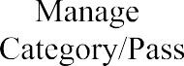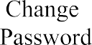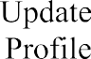







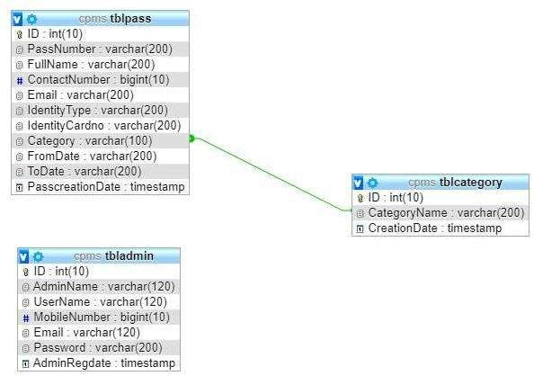



















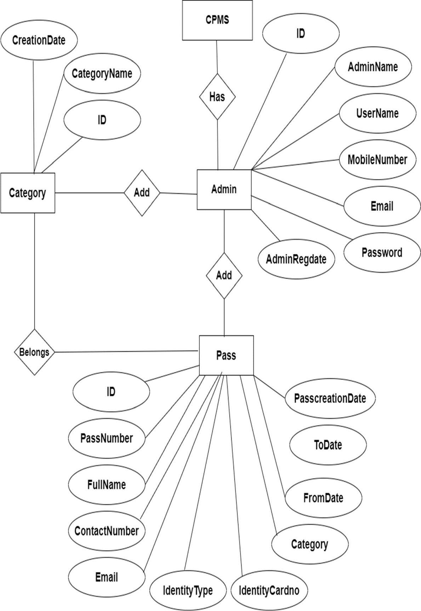









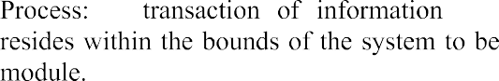



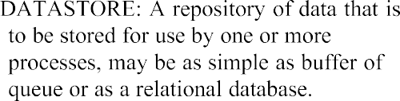































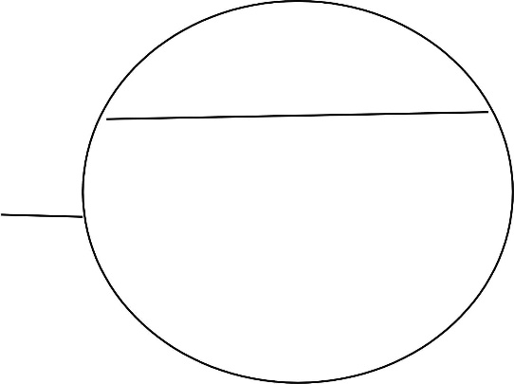



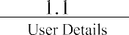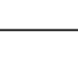

















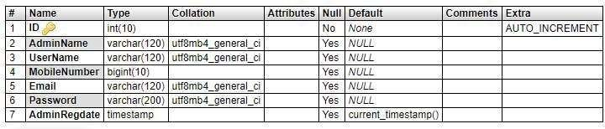



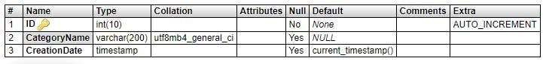

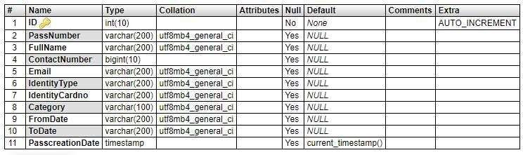

































































































































# 





 **6.1 TYPES OF TESTING**

**6.1.1 Unit testing**

 **6.1.2 Integration testing**

**6.1.3 Functional test**







 **6.1.4 System Test**

 **6.1.5 White Box Testing**



 **6.1.6 Black Box Testing**





 **6.1.7 Unit Testing**





















|  |  |  |  |  |  |
| --- | --- | --- | --- | --- | --- |
|  |  |  |  |  |  |
|  |  |  |  |  |  |
|  |  |  |  |  |  |
|  |  |  |  |  |  |
|  |  |  |  |  |  |
|  |  |  |  |  |  |
|  |  |  |  |  |  |
|  |  |  |  |  |  |
|  |  |  |  |  |  |



To conclude the description the project: The project, developed using PHP, and MySQL is based on the requirement specification of the user the analysis of the existing system, with flexibility for future enhancement.

The project titled as Lockdown E-Pass System was deeply studied and analyzed to design the code and implement. It was done under the guidance of the experienced project guide. All the current requirement and possibilities have been taken care during the project time. Lockdown E-pass System is a software package, which can be used in Lockdown for managing the pass of people.

Lockdown E-Pass System is web-based applications that will manage the record of pass which is issue by administrative and also help to provide online lockdown pass to people who need to travel compulsory. Lockdown E-Pass System is an automatic system which delivers data processing in very high speed in systematic manner.

Many features of our project are its simplicity, accuracy, and its user-friendly interface. Our software incorporates all features and facilities provided by the visual studio software. This project has been developed to manage the entire working of the Lockdown E-Pass System administrative. Out software simplifies and replace all the manual effort and the paper works done by the administrative to a completely electronically environment. Hence both the user and the administrative are at their ease. The user is serviced at his footsteps wherein he just type in the request and he is just a click away.

































**10.USER MANUAL**



**Home Page :-**  This is landing page of web applications, From here , user can check the pass details by pass id.

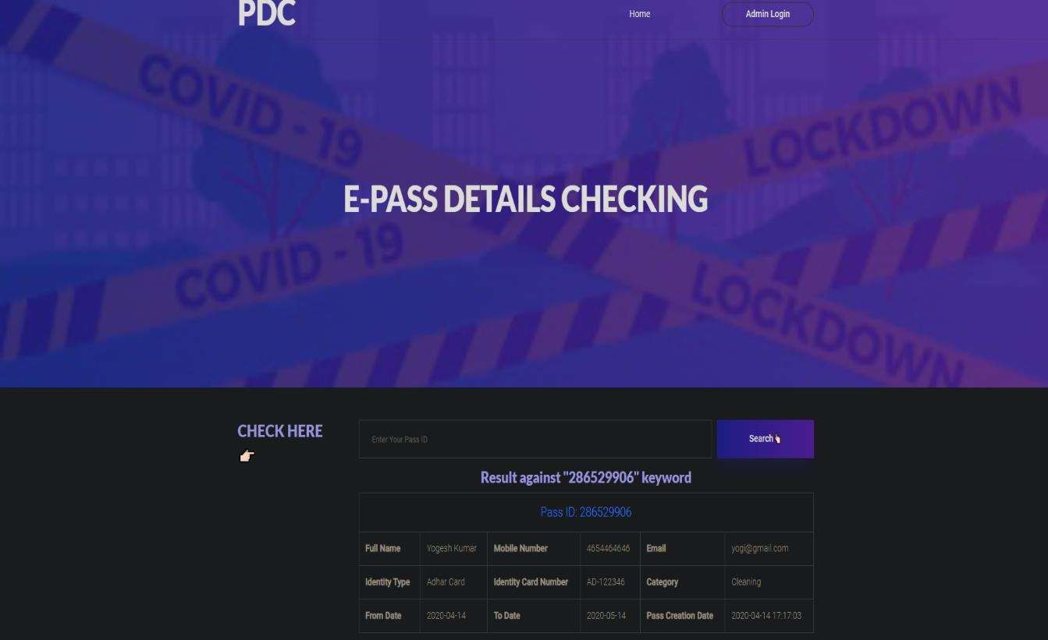

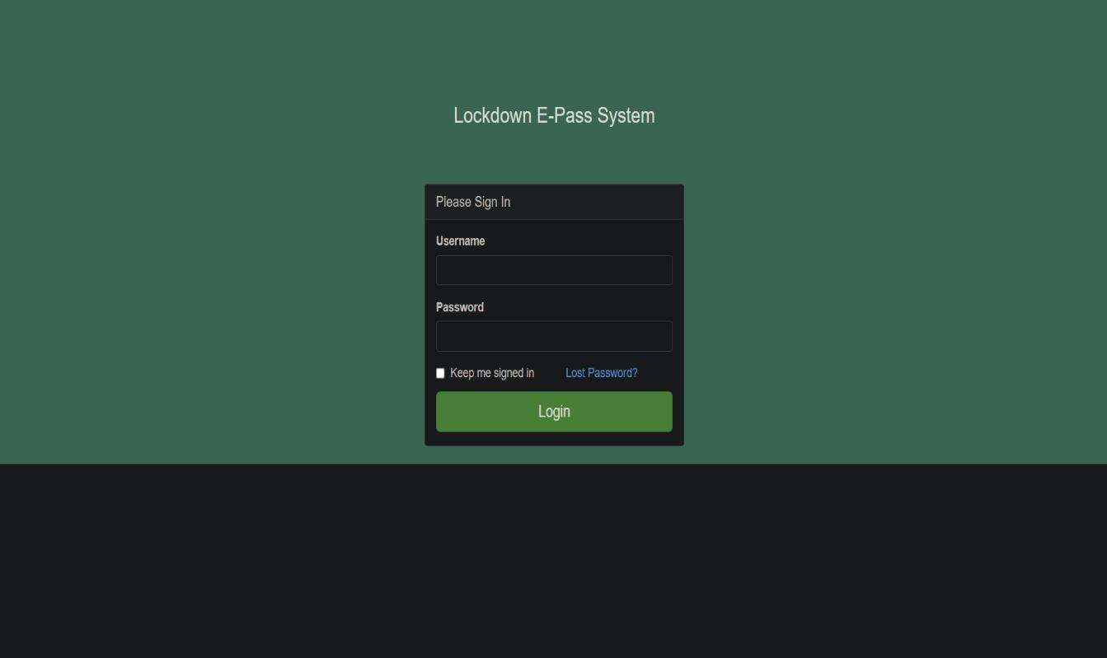**Admin Login :-** This is the login interface for admin

**Dashboard :-** Once the admin logged in, this page is the landing page .

It display all the necessary things to the admin

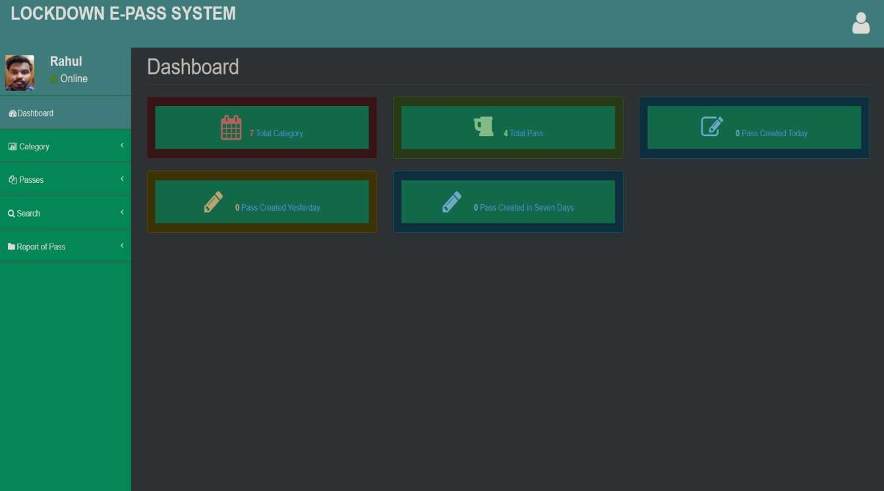

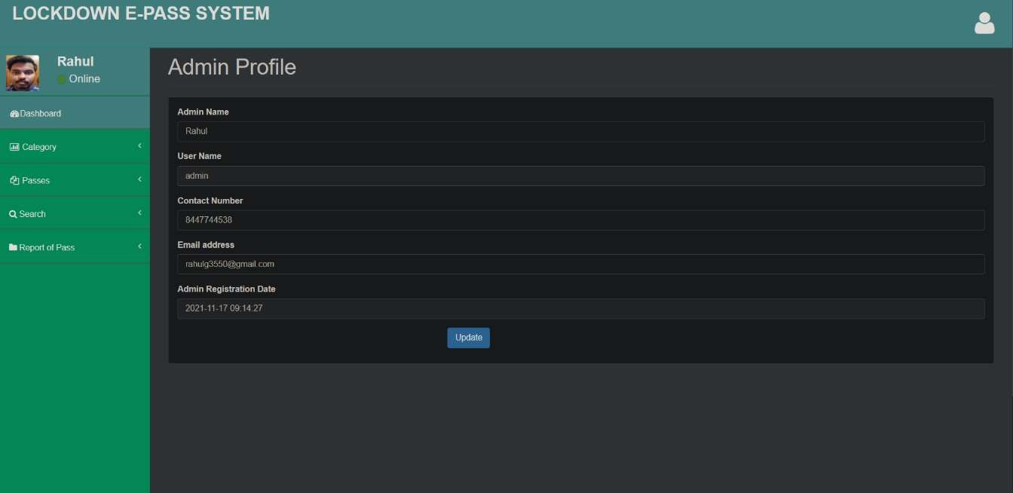**Admin Profile :-** In this section, admin can update admin profile.

**Admin Pass :-** In this section ,admin can add pass details

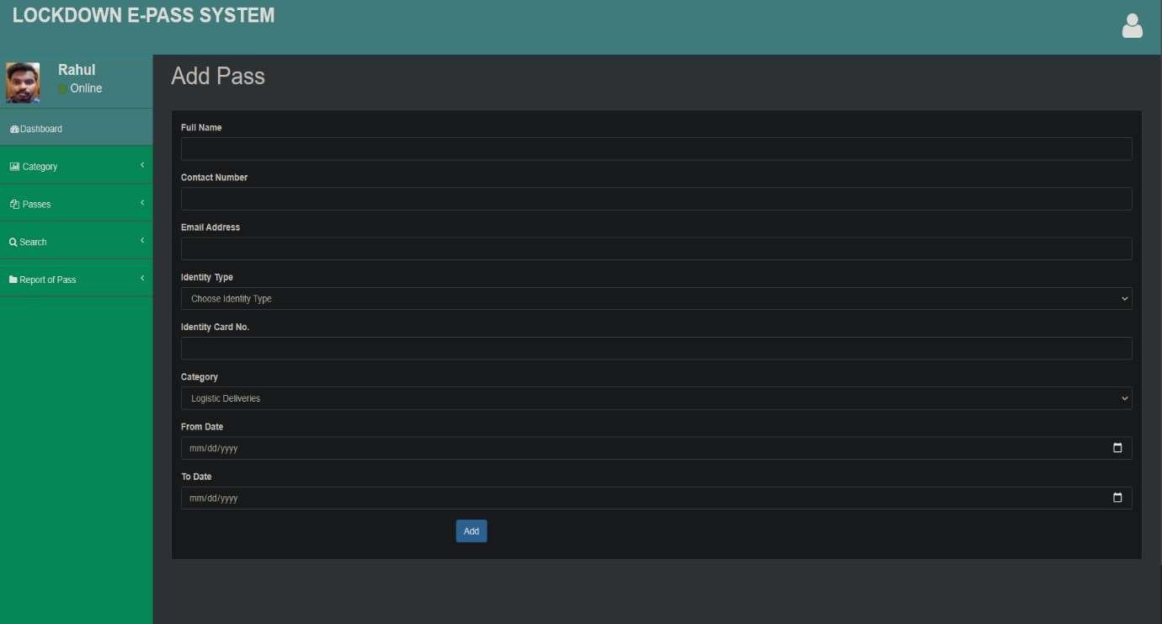

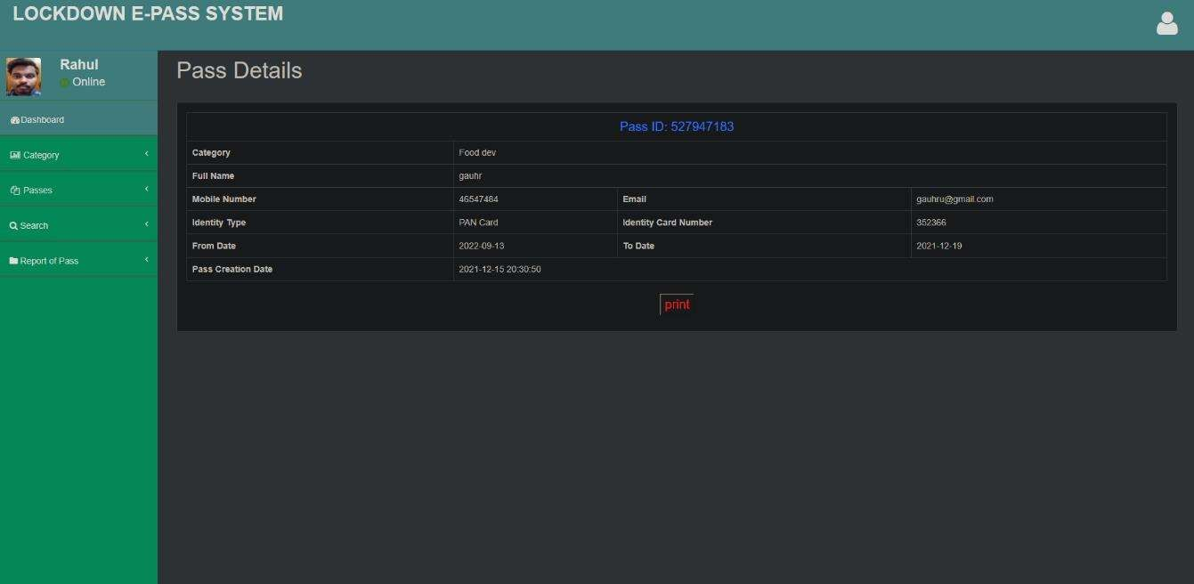**Pass Details :-** In this section, it show the pass details.

**Change Password :-** In this section, admin can change password.

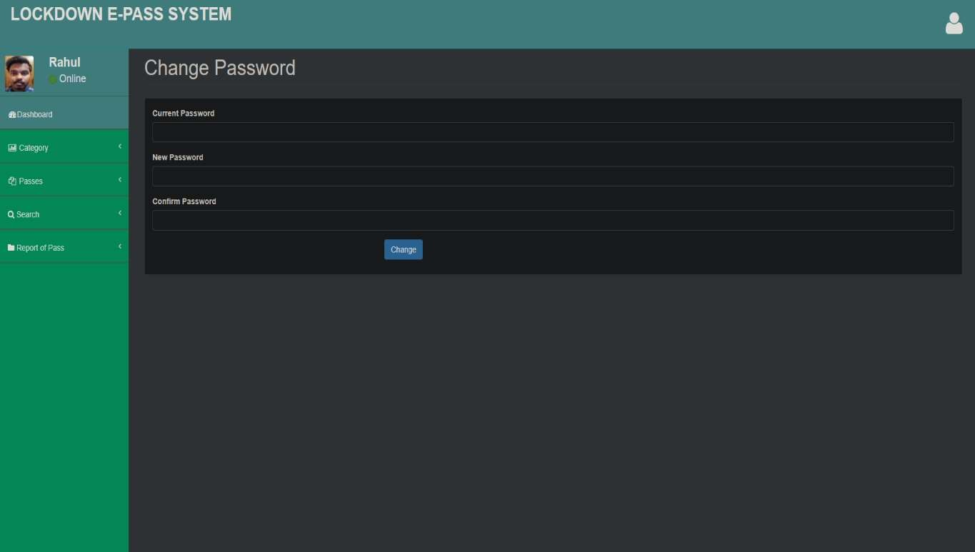

**Forget Password :-** In this section, admin can reset the password.

